Software Requirement Specification (SRS)

Virtual Letter of Life (VLOL) Application

Version 2.0

Sefanit Urgessa

Mohammed Allibalogun

Robert Garcia

Meron Getachew Debela

Charles Baisie

Augustin Mwamba

Jamal Bourne

SWEN 670 Software Engineering Project

University of Maryland Global Campus

Date: 07/21/2020

**REVISION HISTORY**

|  |  |  |
| --- | --- | --- |
| **Date** | **Version** | **Description** |
| 06/09/2020 | 1.0 | Initial SRS Document Release |
| 06/30/2020 | 2.0 | Version includes feedback from Dr. Mir Assadullah |
| 07/21/2020 | 3.0 | Version includes feedback from Dr. Mir Assadullah |
|  |  |  |

**Table of Contents**

1. Introduction 6
   1. Purpose 6
   2. Intended Audience 6
   3. Definitions, Acronyms and Abbreviations 6
   4. Overview 7
2. Scope 7
   1. Scope Description 7
   2. Out of Scope 7
   3. Future Phase 8
3. Overall Description 8
   1. Use-Case Model Survey 8
      1. Required Data …………………………………………………………………….9
   2. User Classes and Permissions 10
   3. Assumptions and Dependencies 10
4. Specific Requirements 10
   1. Functional Requirements-User Stories 11
   2. Use-Case Reports 16
   3. Supplementary Requirements 24
5. Nonfunctional Requirements 24

**APPENDIX A – Graphic User Interface Design** 26

1. Virtual Letter of Life (Desktop) 26
   1. Home 26
   2. Register 27
   3. Login 28
   4. About 29
   5. Contact 30
   6. Privacy 31
2. Virtual Letter of Life (Mobile) 32
   1. Home 32
   2. Register 33
   3. Login 34
   4. About 35
   5. Contact 36
   6. Privacy 37

**Table of Tables**

Table 1 – List of Intended Audiences 5

Table 2 – List of Use-Cases 8

Table 3 – User Classes and Permissions 10

**Table of Figures**

Figure 1 – Letter of Life Form 9

Figure 2 – Home Page 26

Figure 3 – Registration Page 27

Figure 4 – Login Page 28

Figure 5 – About Page 29

Figure 6 – Contact Page 30

Figure 7 – Privacy Policy 31

Figure 8 – Home Page (Mobile) 32

Figure 9 – Registration Page (Mobile) 33

Figure 10 – Login Page (Mobile) 34

Figure 11 – About (Mobile) 35

Figure 12 – Contact US (Mobile) 36

Figure 13 – Privacy Policy Page (Mobile) 37

# Introduction

The Letter of Life is a paper form that provides first responders with a list of important medical information, such as, medical conditions, medications and allergies regarding a Participant in need. Currently, this form is completed by a Participant and placed inside the residence at a location that is easily accessible by EMS personnel. However, when/if an emergency occurs outside of Participants’ home and if the Participant is unresponsive, it is difficult for EMS personnel to have access to the Participant’s medical information. Thus, we are proposing a solution that is a Web-based version of this letter, Virtual Letter of Life. Virtual Letter of Life will provide the same level of Participant’s medical information to first responders.

## Purpose

The purpose of this Software Requirement Specification (SRS) is to collect requirements for Virtual Life of Letter in conjunction with the client, to achieve an effective alignment between client and project team - EMSPlus for the proposed solution.

The proposed software will implement the following 16 use cases:

|  |  |
| --- | --- |
| 1. Admin Edit | 9. User View |
| 2. Admin Delete | 10. User Delete |
| 3. Admin View | 11. Log In |
| 4. Admin Listing | 12. Log Out |
| 5. User Listing | 13. Contact |
| 6. Scan | 14. Search |
| 7. User Register | 15. Home |
| 8. User Edit | 16. Privacy Policy |

## Intended Audience

*Table 1 - List of Intended Audiences*

|  |  |  |
| --- | --- | --- |
| **#** | **Name** | **Role** |
| 1 | Captain Chris Truitt | Stakeholder |
| 2 | Dr. Mir Assadullah. | Stakeholder |
| 4 | Roy Gordon | PM/ Subject matter expert |
| 5 | Robert Garcia | Product Owner | Backend Developer |
| 6 | Sefanit Urgessa | Project Manager | UI/UX Developer |
| 7 | Mohammed Allibalogun | Project Manager | Backend Developer |
| 8 | Meron Getachew Debela | Documentation |
| 9 | Charles Baisie | Security | UI/UX Developer |
| 10 | Augustin Mwamba | Database Developer |
| 11 | Jamal Bourne | UI/UX Developer |
| 12 | UMGC DevOps | UMGC DevOps team |

## Definitions, Acronyms and Abbreviation

The terms and abbreviations used on this SRS relating to the software being developed:

* EMS – Emergency Medical Services.
* QR code – Quick Response code.
* EMT – Emergency Medical Technician.
* EMR – Electronic Medical Record.
* CRUD – Create, Read, Update and Delete.
* CRISP – Chesapeake Regional Information System for our Participants- a regional health information exchange system which enables electronic transfer of clinical information between different DC and Maryland health information systems.
* Sys Admin – The system administrator who has a super user role.
* SQL – Structured Query Language
* HTML – Hypertext Markup Language
* NIST SP – National Institute of Standards and Technology Special Publication
* PII – Personal Identifiable Information
* 2FA – 2 Factor Authentication
* AC – All Controls
* AU – Audit
* IA – Information Assurance
* SC – Systems and Communications
* SI – System & Information Integrity
* W3C – World Wide Web Consortium
* LOL – Letter of Life
* VLOL – Virtual Letter of Life

## Overview

This section describes the overview of the entire document and provides a brief introduction for each section:

**Section 1:** This section introduces the problem, the purpose of the project, intended audience and definitions/abbreviations.

**Section 2:** This section discusses the scope of the project, what is out of scope and future phases.

**Section 3:** This section discusses the overall description of the project, assumptions and dependencies.

**Section 4:** This section describes specific requirements of the system - use cases.

# Scope

The goal of this project is to develop a web-based software that will allow emergency medical responders to retrieve medical information, such as allergies, medication and medical conditions, which is contained in a Participant’s Letter of Life, from any location using a web interface.

## Scope Description

* Provide EMS personnel access to a Participant’s Letter of Life information, from a laptop and mobile devices through a secure web interface.
* Allow EMS personnel to scan QR code to retrieve Letter of Life information for non-responsive Participants.
* Allow Participants and authorized users to create, update, read and delete Participants’ medical records through a secure interface.

## Out of Scope

* Integration of product with the current Information Technology infrastructure of City of Salisbury, MD System.
* Hands-on training of end users.

## Future Phase

The following are to be completed in a future phase – timeline is to-be-determined upon the agreement of Version II development of Virtual Letter of Life:

Future functionalities

* Integration with Chesapeake Regional Information System for our Participants (CRISP ), a regional electronic health information exchange system, which will be used to update Virtual Letter of Life automatically.
* Reminder email: ability for the system to send reminder emails for Participant to update their medical record.

# Overall Description

The basic functionality of the system is to provide EMS personnel access to Participant’s Letter of Life information from a mobile device by scanning QR code or performing a search. The system will also allow Participants and authorized users to create, read, update and delete records using web interface.

## Use-Case Model Survey

The table below lists the use cases that make up the basic requirements for the virtual letter of life, which is constructed based on the existing paper Letter of Life form. The details of each use case are located in section 4 of this document.

*Table 2 - List of Use-Cases*

|  |  |  |
| --- | --- | --- |
| **ID** | **Use Case** | **Description** |
| 1 | Admin Edit | Edits existing account. |
| 2 | Admin Delete | Removes user from the system. |
| 3 | Admin View | Displays user information. |
| 4 | Admin Listing | Lists existing users of the system. |
| 5 | User Listing | Lists existing Participants. |
| 6 | Search | Enables EMT personal to initiate search for a Participant. |
| 7 | Scan | Allows EMT personal to scan QR code and retrieve Participant’s LOL information. |
| 8 | User Add | Adds Participant into the system. |
| 9 | User Edit | Edits existing Participant information. |
| 10 | User View | Displays Participant information. |
| 11 | User Delete | Removes Participant information from system. |
| 12 | Log In | Enables user to login to the system. |
| 13 | Log Out | Enables user to log out of the system. |
| 14 | Contact | Displays contact information. |
| 15 | Home | Displays the landing page of VLOL. |
| 16 | Privacy Policy | Displays the privacy policy for VLOL. |

* + 1. **Required Data**

The required data is derived directly from the existing Letter of Life that is currently in use by EMS (see below).

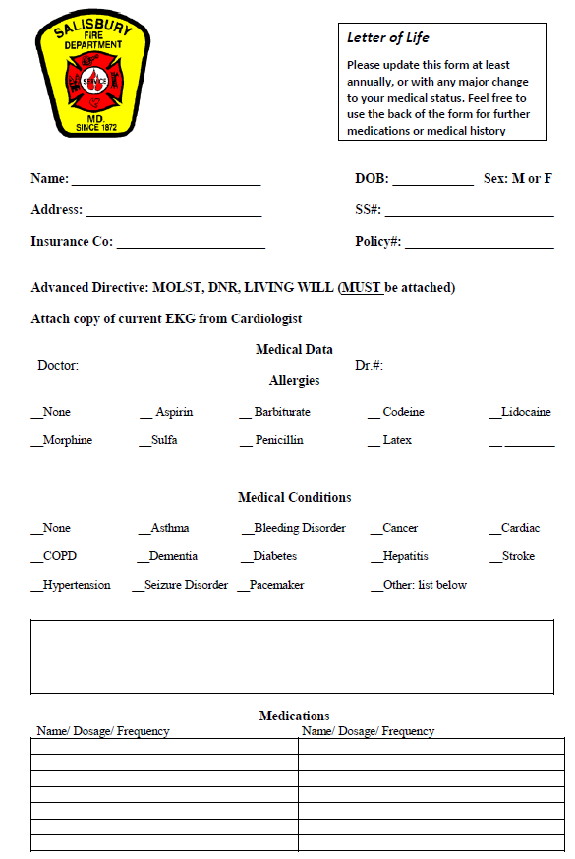

Figure 1 - Letter of Life Form

## User Classes and Permissions

User Classes include: System Administrator, Participant Advocate, EMS Personnel, Program Participant, and Unauthenticated and Unauthorized User.

* **System Administrator (Admin)** – may modify and remove user from the system. Also has a super role access and the ability to view list of users of the application.
* **Participant Advocate** – may update Participants’ information on behalf of the Participant.
* **EMS Personnel** – may access Participants’ Letter of Life information. EMT personnel has view access only.
* **Program Participant (User)** – may enter letter of life information into the Virtual Letter of Life after creating an account. Also has additional capabilities to edit information and delete account.
* **Unauthenticated and Unauthorized User** – has view access only.

*Table 3 - User Classes and Permissions*

|  |  |  |  |  |  |
| --- | --- | --- | --- | --- | --- |
| **User/Permissions** | **System Admin** | **Participant Advocate** | **EMS Personnel** | **Program Participant** | **Unauthenticated and Unauthorized User** |
| Enter LOL (Letter of Life) |  |  |  | X |  |
| Update LOL |  | X |  | X |  |
| Delete LOL |  |  |  | X |  |
| View LOL |  |  | X |  |  |
| Register as User |  |  |  | X |  |
| Delete Users | X |  |  |  |  |
| Modify User access | X |  |  |  |  |
| View Users | X |  |  |  |  |
| View general info pages of VLOL | X | X | X | X | X |

## Assumptions and Dependencies

This project is expected to focus on providing the Virtual Letter of Life, electronic medical record (EMR) to emergency medical responders. Thus, our assumption is that internet bandwidth is always up and functioning on the devices that will be used to access the virtual letter.

# Specific Requirements

This section presents specific functional requirements for the Virtual Letter off Life application. Section 4.1 provides list of requirements in user story format, followed by the use cases reports, which will be used to ensure the functionality are addressed.

## Functional Requirements- User Stories

Table 4 User Stories and Acceptance Criteria

| **ID** | **User Stories** | **Acceptance Criteria** |
| --- | --- | --- |
| REQ-1.1 | As an unauthenticated and unauthorized user, I want access to an informative Landing page, so I can learn about the Letter of Life (LOL) program. | * View a homepage that introduces the LOL program. |
| REQ-1.2 | As an unauthenticated and unauthorized user, I want access to a Contact page, so I can solicit information about the LOL program or contact the System Administrator about an issue. | * View a Contact page for information solicitation about the LOL. * Contact the System Administrator about an issue. |
| REQ-1.3 | As an unauthenticated and unauthorized user, I want access to a secure Registration page, so I can enroll in the Letter of Life program. | * Enroll in the LOL program using a secure Registration page. |
| REQ-1.4 | As a registered, authenticated, and authorized Program Participant, I want to access my LOL via a Login Page, so unauthenticated and unauthorized users cannot access my medical history. | * Login to LOL account via the Login Page by providing username and password. |
| REQ-1.5 | As a registered, authenticated, and authorized Program Participant, I want to add my LOL information to the database via an online form, so medical personnel can have access to my medical history in case of an emergency. | * Add medical history into LOL database. |
| REQ-1.6 | As a registered, authenticated, and authorized Program Participant, I want to view my LOL information via an online form, so I can validate my information or print my LOL. | * View and validate medical history. |
| REQ-1.7 | As a registered, authenticated, and authorized Program Participant, I want to edit my LOL information via an online form, so I can ensure my medical history is up to date. | * Edit medical history. |
| REQ-1.8 | As a registered, authenticated, and authorized Program Participant, I want to delete my LOL information from the database via an online form, so I may stop participating in the program. | * Delete medical history. |
| REQ-1.9 | As a registered, authenticated, and authorized Program Participant, I want to print a barcode or quick response (QR) code with a link to my LOL (which I may affix to a bracelet, card, or necklace), so medical personnel can quickly access my medical history in case of an emergency. | * Print QR code or barcode with a link to LOL account. |
| REQ-1.10 | As a registered, authenticated, and authorized Program Participant, I want access to a secure Contact page, so I can contact my Participant Advocate (if designated) and/or the System Administrator about an issue. | * Contact Participant Advocate or System Administrator about LOL. |
| REQ-1.11 | As a registered, authenticated, and authorized Medical Services Provider, I want to access the LOL system via a Login Page, so unauthenticated and unauthorized users cannot access a Participant's medical history. | * Login to VOL system via Login Page. |
| REQ-1.12 | As a registered, authenticated, and authorized Medical Services Provider, I want to edit my profile information via an online form, so I can ensure my information is up to date. | * Edit provider profile information. |
| REQ-1.13 | As a registered, authenticated, and authorized Medical Services Provider, I want to search for Participants on a laptop or mobile device via an online form, so I can retrieve their medical history and provide correct medical care. | * Search for Participants medical history. |
| REQ-1.14 | As a registered, authenticated, and authorized Medical Services Provider, I want to search for a Participant by scanning a barcode or quick response (QR) code, using a mobile device or authorized accessory, so I can retrieve their medical history and provide correct medical care. | * Scan QR code and retrieve Participant medical history. |
| REQ-1.15 | As a registered, authenticated, and authorized Medical Services Provider, I want to view a Participant's medical history on a laptop or mobile device via an online form, so I can provide correct medical care. | * View Participant’s medical history. |
| REQ-1.16 | As a registered, authenticated, and authorized Medical Services Provider, I want to print a MIEMSS-approved Short Form, populated with my Participant's information, so I can provide non-system medical facilities and staff with my Participant's medical history. | * Print a MIEMSS-approved Short Form with populated Participant’s information. |
| REQ-1.17 | As a registered, authenticated, and authorized Medical Services Provider, I want access to a secure Contact page, so I can contact the System Administrator about an issue. | * Contact System Administrator about an issue. |
| REQ-1.18 | As a registered, authenticated, and authorized Participant Advocate, I want to access the LOL system via a Login Page, so unauthenticated and unauthorized users cannot access the medical history of my Participants. | * Login to LOL via Login Page. |
| REQ-1.19 | As a registered, authenticated, and authorized Participant Advocate, I want to edit my profile information via an online form, so I can ensure my information is up to date. | * Edit profile information. |
| REQ-1.20 | As a registered, authenticated, and authorized Participant Advocate, I want to search for Participants on a laptop or mobile device via an online form, so I can view, edit, and print Participant information, as necessary. | * Search for Participant information. |
| REQ-1.21 | As a registered, authenticated, and authorized Participant Advocate, I want to search for a Participant by scanning a barcode or quick response (QR) code, using a mobile device or authorized accessory, so I can view, edit, and print Participant information, as necessary. | * Scan QR code or barcode to search for Participant’s information. |
| REQ-1.22 | As a registered, authenticated, and authorized Participant Advocate, I want to view the LOL information of my Participants via an online form, so I can validate their information or print their LOL. | * View LOL information of Participants. |
| REQ-1.23 | As a registered, authenticated, and authorized Participant Advocate, I want to edit the LOL information of my Participants via an online form, so I can ensure their medical history is up to date. | * Edit LOL information of Participants. |
| REQ-1.24 | As a registered, authenticated, and authorized Participant Advocate, I want to print a barcode or quick response (QR) code with a link to my Participant's LOL (which I may affix to a bracelet, card, or necklace), so medical personnel can quickly access their medical history in case of an emergency. | * Print a QR code or barcode with a link to Participant’s LOL. |
| REQ-1.25 | As a registered, authenticated, and authorized Participant Advocate, I want access to a secure Contact page, so I can contact the System Administrator about an issue. | * View Contact page * Contact System Administrator about issue. |
| REQ-1.26 | As a registered, authenticated, and authorized System Administrator, I want to access the LOL system via a Login Page, so unauthenticated and unauthorized users cannot access Participant medical history or user account information. | * Login to LOL using username and password via the Login Page. |
| REQ-1.27 | As a registered, authenticated, and authorized System Administrator, I want to search for user accounts on a laptop or mobile device via an online form, so I can add, view, edit, and delete user accounts, as necessary. | * Search for user accounts. |
| REQ-1.28 | As a registered, authenticated, and authorized System Administrator, I want to add accounts for Medical Services Providers and Participant Advocates, so I can limit non-Participant access to Participant information. | * Add accounts for EMS Providers and Participant Advocates. |
| REQ-1.29 | As a registered, authenticated, and authorized System Administrator, I want to view accounts for Medical Services Providers and Participant Advocates, so I can validate their information. | * View EMS Providers and Participant Advocates accounts. |
| REQ-1.30 | As a registered, authenticated, and authorized System Administrator, I want to edit accounts for Medical Services Providers and Participant Advocates, so I can ensure their information is up to date. | * Edit EMS Providers and Participant Advocates accounts. |
| REQ-1.31 | As a registered, authenticated, and authorized System Administrator, I want to delete accounts for Medical Services Providers and Participant Advocates, so I can limit non-Participant access to Participant information. | * Delete EMS Providers and Participant Advocates accounts. |
| REQ-1.32 | As a registered, authenticated, and authorized System Administrator, I want to search for Participants on a laptop or mobile device via an online form, so I can add, view, edit, and delete Participant information, as necessary. | * Search for Participants information. |
| REQ-1.33 | As a registered, authenticated, and authorized System Administrator, I want to add accounts for Participants, so I can enroll them in the program. | * Register Program Participants. |
| REQ-1.34 | As a registered, authenticated, and authorized System Administrator, I want to view accounts for Participants, so I can validate their information. | * View Participants account information. |
| REQ-1.35 | As a registered, authenticated, and authorized System Administrator, I want to edit accounts for Participants, so I can ensure their information is up to date. | * Edit Participants account information. |
| REQ-1.36 | As a registered, authenticated, and authorized System Administrator, I want to delete accounts for Participants, so I can disenroll them from the program. | * Delete Participants account information. |
| REQ-1.37 | As a registered, authenticated, and authorized System Administrator, I want to view a system error log, so I can inform the development team of problems or issues with the application. | * View system error log. |
| REQ-1.38 | As a registered, authenticated, and authorized System Administrator, I want to view a system activity log, so I can audit access and use of the system. | * View system activity log. |
| REQ-1.39 | As a registered, authenticated, and authorized System Administrator, I want to have access to the user guide, so I provide users with instructions on how to use the system. | * Access the user guide. |

## Use-Case

There are 16 use cases that makes up the basic functionality of the virtual letter of life web interface. The description of each use cases is described in the below section.

1. **Use Case Name:** **Admin Edit**

**Summary:** The Admin Edit feature allows the sys admin to modify an existing user profile.

**Requirement ID:** REQ-1.30, and REQ-1.35

|  |  |
| --- | --- |
| **Actor** | System Administrator |
| **Trigger** | The system admin triggers the Edit feature event. |
| **Precondition** | System administrator has a super user role access and a user has an existing profile. |
| **System Response** | System displays current user information and prompt admin to make change as needed. |
| **Post Condition** | Modified user information displayed. |
| **Alternative Path** | Cancel editing user information. |

1. **Use Case Name: Admin** **Delete**

**Summary:** The Admin Delete feature enables the sys admin to remove an existing user form the system.

**Requirement ID:** REQ-1.31, and REQ-1.36

|  |  |
| --- | --- |
| **Actor** | System Administrator |
| **Trigger** | The system admin triggers the Admin Delete event. |
| **Precondition** | System administrator has a super user role access and a user have existing profile. |
| **System Response** | System displays existing user information and prompt admin to delete user. |
| **Post Condition** | User removed from the system. |
| **Alternative Path** | Cancel deletion. |

1. **Use Case Name: Admin View**

**Summary:** The Admin View feature allows the sys admin to view a specific user information.

**Requirement ID:** REQ-1.27

|  |  |
| --- | --- |
| **Actor** | System Administrator |
| **Trigger** | The system admin triggers the Admin View event. |
| **Precondition** | System administrator has a super user role access and there are existing user profiles. |
| **System Response** | System displays existing user information. |
| **Post Condition** | User information displayed. |
| **Alternative Path** | None. |

1. **Use Case Name: Admin** **Listing**

**Summary:** The Admin Listing feature allows the sys admin to view lists of users that are in the virtual letter of life database.

**Requirement ID:** REQ-1.29, and REQ-1.34

|  |  |
| --- | --- |
| **Actor** | System Administrator |
| **Trigger** | The system admin triggers the Admin Listing event. |
| **Precondition** | System administrator has a super user role access. |
| **System Response** | System displays list of users. |
| **Post Condition** | List of existing users displayed. |
| **Alternative Path** | None. |

1. **Use Case Name: User Listing**

**Summary:** The User Listing feature allows EMT personnel to view lists of Participants’ that are in the virtual letter of life database.

**Requirement ID:** REQ-1.29

|  |  |
| --- | --- |
| **Actor** | EMT personnel |
| **Trigger** | EMT personnel triggers the User Listing event. |
| **Precondition** | EMT personnel authenticated and Participants’ information is in the virtual life of letter database. |
| **System Response** | System allows user to view list of participants. |
| **Post Condition** | List of existing participants displayed. |
| **Alternative Path** | None. |

1. **Use Case Name**: **Search**

**Summary:** The Search feature provides the ability to search for a participant.

**Requirement ID:** REQ-1.13, REQ-1.20, and REQ-1.27

|  |  |
| --- | --- |
| **Actor** | EMT personnel, system admins and Participants. |
| **Trigger** | User triggers Search event. |
| **Precondition** | User have the appropriate permission to search. |
| **System Response** | System prompt user to scan QR code. |
| **Post Condition** | User scan QR code. |
| **Alternative Path** | Cancel Search. |

1. **Use Case Name: Scan**

**Summary:** The Scan feature allows EMT personnel to scan barcode or QR code and search participant’s letter of life from the virtual letter of life database.

**Requirement ID:** REQ-1.13, REQ-1.14, and REQ-1.21

|  |  |
| --- | --- |
| **Actor** | EMT personnel |
| **Trigger** | EMT personnel triggers the Scan event. |
| **Precondition** | EMT personnel authenticated and Participant information is in the virtual life of letter database. |
| **System Response** | System prompts user to scan barcode or QR code. |
| **Post Condition** | Participant letter of life displayed on the screen. |
| **Alternative Path** | Cancel search. |

1. **Use Case Name: User Register**

**Summary:** The User register as a participant user to create an account.

**Requirement ID:** REQ-1.3

|  |  |
| --- | --- |
| **Actor** | Participant |
| **Trigger** | Participant triggers the User Add event. |
| **Precondition** | None. |
| **System Response** | System displays list of questions for the participant to complete and save. |
| **Post Condition** | Participant information is added into the database. |
| **Alternative Path** | Cancel and no account gets created. |

1. **Use Case Name: User** **Edit**

**Summary:** The User Edit feature allows participant to edit existing information.

**Requirement ID:** REQ-1.7, REQ-1.12, and REQ-1.23

|  |  |
| --- | --- |
| **Actor** | Participant |
| **Trigger** | Participant  triggers User Edit event. |
| **Precondition** | Participant have an existing account. |
| **System Response** | System displays existing information and prompt user to modify information as needed. |
| **Post Condition** | The modified information gets stored in the database. |
| **Alternative Path** | Cancel change and nothing gets modified. |

1. **Use Case Name: User** **View**

**Summary:** The User View feature allows Participant to view his/her account information.

**Requirement ID:** REQ-1.6, REQ-1.15, REQ-1.22, and REQ-1.25

|  |  |
| --- | --- |
| **Actor** | Participant |
| **Trigger** | Participant triggers User View event. |
| **Precondition** | Participant have an existing account. |
| **System Response** | System displays existing account information. |
| **Post Condition** | Participant account information gets displayed. |
| **Alternative Path** | None. |

1. **Use Case Name: User Delete**

**Summary:** The User Delete feature allows Participant to delete his/her account from the system.

**Requirement ID:** REQ-1.8

|  |  |
| --- | --- |
| **Actor** | Participant |
| **Trigger** | Participant triggers the User Delete event. |
| **Precondition** | Participant have an existing account. |
| **System Response** | System prompt Participant to confirm and proceed with deletion. |
| **Post Condition** | Account gets deleted from the system. |
| **Alternative Path** | Cancel deletion. |

1. **Use Case Name**: **Log In**

**Summary:** The Log In feature allows users (EMT personnel, system admins and Participants) to login into the system.

**Requirement ID:** REQ-1.4, REQ-1.11, REQ-1.18, and REQ-1.26

|  |  |
| --- | --- |
| **Actor** | EMT personnel, system admins and Participants. |
| **Trigger** | User triggers Login option. |
| **Precondition** | User must be authenticated and have an existing account. |
| **System Response** | System prompts user to enter login information. |
| **Post Condition** | User is logged into virtual letter of life interface. |
| **Alternative Path** | Cancel login. |

1. **Use Case Name**: **Log Out**

**Summary:** The Logout feature allows user to log out of the system.

**Requirement ID:**

|  |  |
| --- | --- |
| **Actor** | EMT personnel, system admins and Participants. |
| **Trigger** | User triggers Logout event. |
| **Precondition** | User is logged into the system. |
| **System Response** | System logs out user from account. |
| **Post Condition** | User is logged out of virtual letter of life interface. |
| **Alternative Path** | None. |

1. **Use Case Name**: **Contact**

**Summary:** The Contact feature provides user with contact information.

**Requirement ID:** REQ-1.2, REQ-1.10, and REQ-1.17

|  |  |
| --- | --- |
| **Actor** | EMT personnel, system admins and Participants. |
| **Trigger** | User triggers Contact event. |
| **Precondition** | User is on virtual letter of life website. |
| **System Response** | System displays contact information. |
| **Post Condition** | Use views contact information page. |
| **Alternative Path** | None. |

1. **Use Case Name**: **Home**

**Summary:** The Home page displays the landing page of VLOL.

**Requirement ID:** REQ-1.1

|  |  |
| --- | --- |
| **Actor** | EMT personnel, system admins and Participants. |
| **Trigger** | User triggers Home event. |
| **Precondition** | User is on virtual letter of life website. |
| **System Response** | System displays the landing page of the site. |
| **Post Condition** | Use views the home page of VLOL. |
| **Alternative Path** | None. |

1. **Use Case Name**: **Privacy Policy**

**Summary:** The Privacy Policy page displays the landing page of VLOL.

**Requirement ID:**

|  |  |
| --- | --- |
| **Actor** | EMT personnel, system admins and Participants. |
| **Trigger** | User triggers Privacy Policy event. |
| **Precondition** | User is on virtual letter of life website. |
| **System Response** | System displays the privacy policy of VLOL. |
| **Post Condition** | Use views the privacy policy page of VLOL. |
| **Alternative Path** | None. |

## Supplementary Requirements

* Software Specifications (from IT directory City of Salisbury):
* Operating System: Linux (Heroku-18 / Ubuntu 18.04)
* Web Server: Tomcat Embedded Jasper (10.0.0-M6)
* Database Server: H2 (Development) / MySQL (Development / Production)
* Database Language: SQL
* Languages and Framework: Java (Spring Boot) / HTML / CSS / JavaScript
* Repository: GitHub/UMGC Git Repositories
* Development Hosting: Heroku (<https://warm-hamlet-22515.herokuapp.com/>) using 2048-bit SSL/TLS
* Production Hosting: Heroku / TBD

# Nonfunctional Requirements

Nonfunctional requirements of the virtual letter of life interface are:

NF-1.1: Limit Create-Read-Update-Delete (CRUD) access to authenticated and authorized users only, to preserve the confidentiality and integrity of Personally Identifiable Information (PII).

NF-1.2: New registrants shall verify their accounts via a link sent via email (2FA) to mitigate the creation of fake accounts.

NF-1.2: All non-verified accounts to be deleted within 24 hours to prevent database bloating.

NF-1.3: All user input should be validated to prevent injection and scripting attacks.

NF-1.4: User sessions should timeout within 30 minutes to prevent inadvertent disclosure of PII.

NF-1.5: Limit multi-account access to authorized devices only (MAC Whitelisting) to preserve the confidentiality and integrity of PII, as well as the availability of the system.

NF-1.6: The following NIST SP 800-53 controls enforced throughout the application to preserve the confidentiality and integrity of PII, as well as the availability of the system:

* + AC-2: ACCOUNT MANAGEMENT
  + AC-3: ACCESS ENFORCEMENT
  + AC-7: UNSUCCESSFUL LOGON ATTEMPTS
  + AC-8: SYSTEM USE NOTIFICATION
  + AC-11: SESSION LOCK
  + AC-12: SESSION TERMINATION
  + AU-2: AUDIT EVENTS
  + AU-8: TIME STAMPS
  + IA-2: IDENTIFICATION AND AUTHENTICATION (ORGANIZATIONAL USERS)
  + SC-13: CRYPTOGRAPHIC PROTECTION
  + SC-23: SESSION AUTHENTICITY
  + SI-10: INFORMATION INPUT VALIDATION
  + SI-11: ERROR HANDLING

NF-1.7: All SQL queries to use prepared statements to prevent SQL injection attacks.

NF-1.8: All tables to be normalized to 3rd Normal Form to improve data integrity and reduce data redundancy.

NF-1.9: Unit test all functions and methods to ensure boundary conditions are not violated.

NF-1.10: Incorporate static code analysis, using both automated and manual methods to ensure there are no weaknesses due to code syntax.

NF-1.11: Incorporate dynamic code analysis and penetration testing to ensure there are no vulnerabilities due to code semantics.

NF-1.11: Style and comment all code per the appropriate style guide to properly maintain and turn-over the application, as necessary.

NF-1.12: Incorporate version control to audit and track code generation.

NF-1.13: All issues and risks shall be identified during static and dynamic analysis, corrected before uploading to a repository to ensure the repository's code meets the bug bar.

NF-1.14: If identified issue and risk cannot be corrected immediately, it should be recorded in a bug log to ensure the issue or risk is corrected before deployment.

NF-1.15: All presentation code to be HTML5 and W3C compliant to ensure the application provides the same functionality across different platforms.

# APPENDIX A – GRAPHICAL USER INTERFACE DESIGN

## Virtual Letter of Life (Desktop)

### **Home**

### **Screen Name:** VLOL (Virtual Letter of Life) Home Page

**Requirement ID:** REQ-1.1

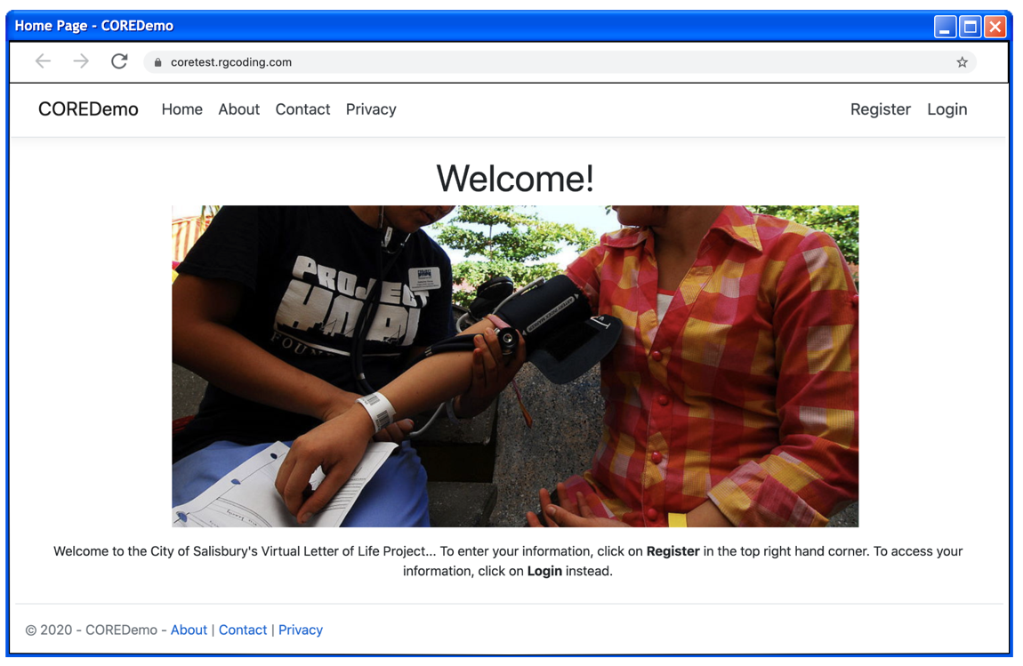

Figure 2 Home Page

**Internal UI functionality**:

When it comes to internal functionality, the systems users are populated when users choose to register within the system. The register option is presented here along with the option to sign in.

**External UI functionality**:

Externally this page presents the user with options to find more information regarding the VLOL system. The options are About, Contact and Privacy.

### **Register**

### **Screen Name: VLOL (Virtual Letter of Life) Registration Page**

**Requirement ID:** REQ-1.3

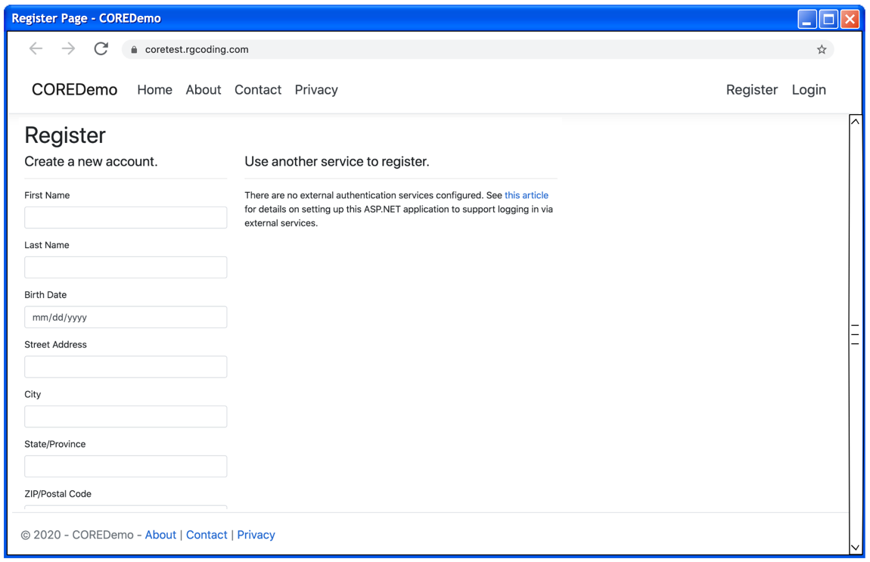

Figure 3 Registration Page

**Internal UI functionality**:

When it comes to internal functionality, the systems users are populated when users choose to register within the system. Registration collects user data: First Name, Last Name, DOB, Address, City, State, Zip, Phone Number, Email, SSN, Insurance Company, Insurance Policy, Primary Doctor, Primary Doctor Phone, Additional Information, and Password.

**External UI functionality**:

The registration page functionality effects external users by allowing them to store user credentials into the system. (Username and Password) this is used to allow access to the system.

### **Login**

### **Screen Name:** VLOL (Virtual Letter of Life) Log In Page

**Requirement ID:** REQ-1.4, REQ-1.11, REQ-1.18, and REQ-1.26

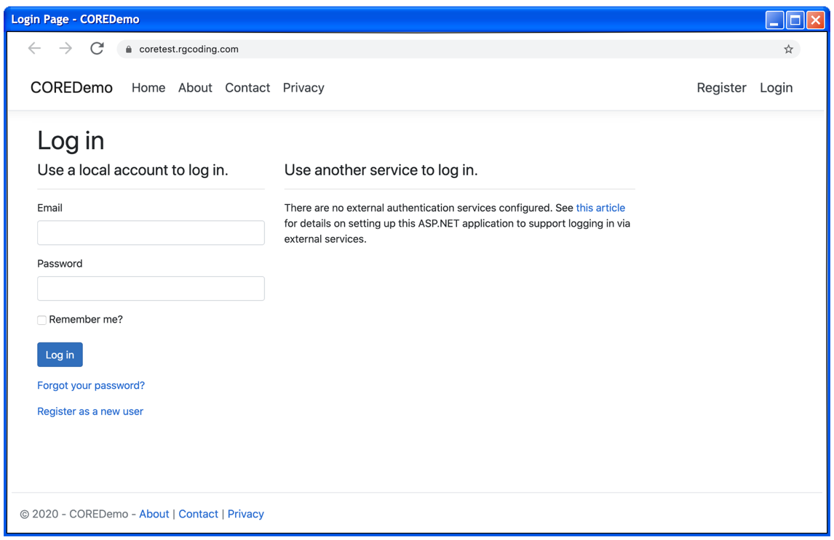

Figure 4 Login Page

**Internal UI functionality**:

This login page does not provide any internal functionality.

**External UI functionality**:

This is the interface that provides system access to external users upon verification of credentials.

### **About**

### **Screen Name:** VLOL (Virtual Letter of Life) About Page

**Requirement ID:** REQ-1.1

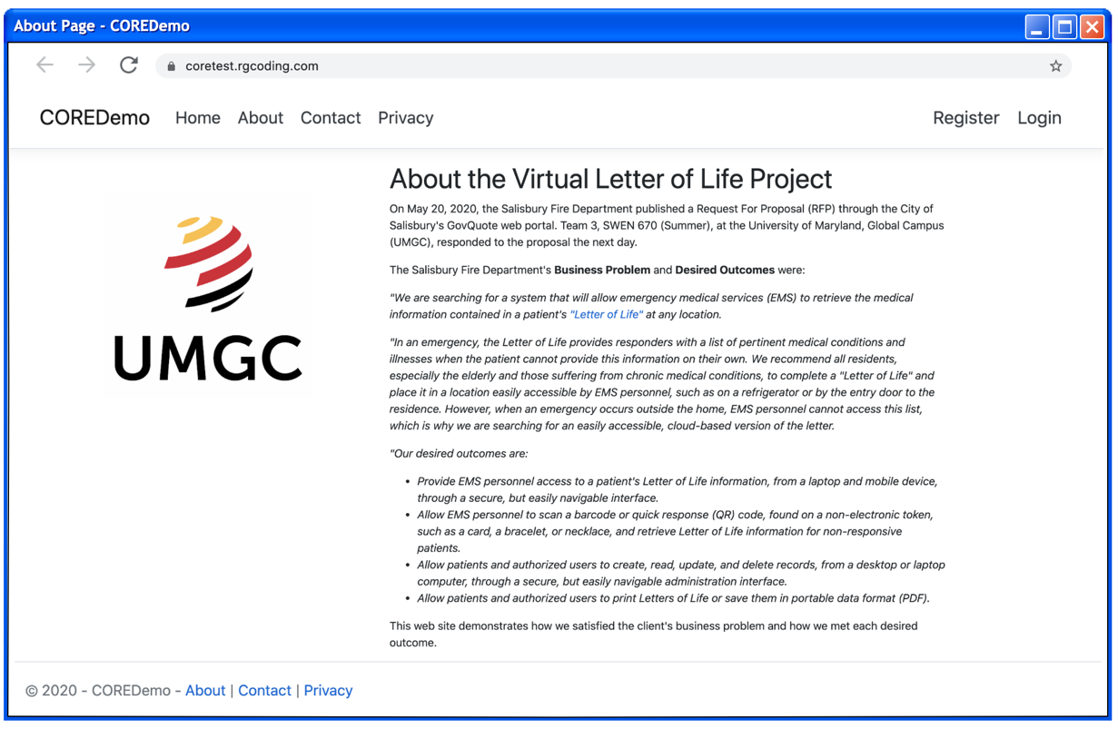

Figure 5 About Page

**Internal UI functionality**:

Internal functionality is not granted to external users from the About Page.

**External UI functionality**:

The About Page is designed to give users a background of the VLOL system and what it is used for.

### **Contact**

### **Screen Name:** VLOL (Virtual Letter of Life) Contact Page

**Requirement ID:** REQ-1.2, REQ-1.10, and REQ-1.17

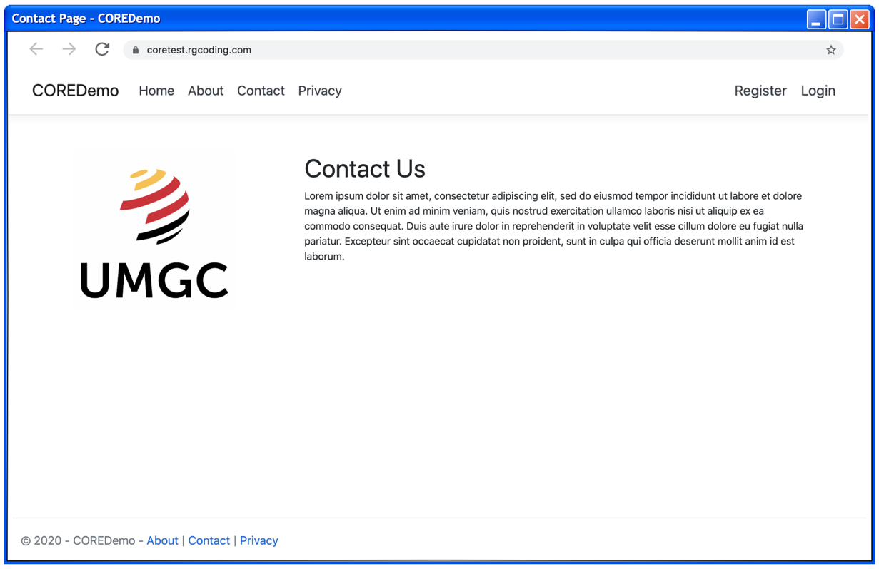

Figure 6 Contact Page

**Internal UI functionality**:

Internal functionality is not present from the Contact Page.

**External UI functionality**:

The Contact Page is designed to give users information regarding contacting the Virtual Letter of Life team.

### **Privacy**

### **Screen Name:** VLOL (Virtual Letter of Life) Privacy Page

**Requirement ID:**

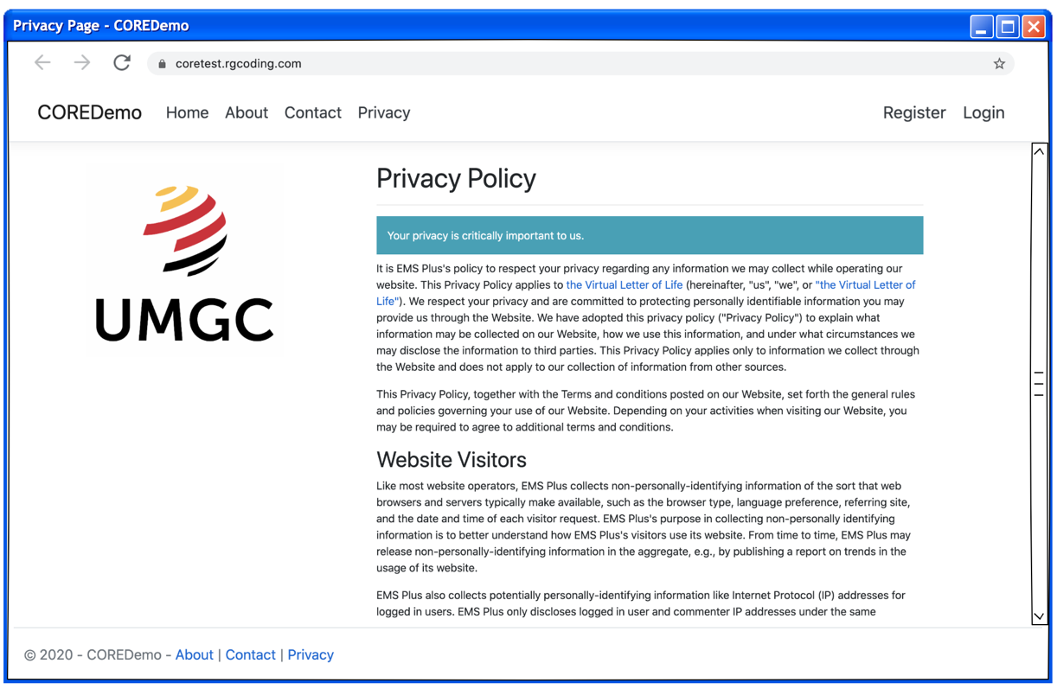

Figure 7 Privacy Policy Page

**Internal UI functionality**:

Internal functionality is not present from the Privacy Page.

**External UI functionality**:

The Privacy Page is designed to provide users with a guarantee of how their private data is to be handled by the Virtual Letter of Life System.

## Virtual Letter of Life (Mobile)

### **Home**

### **Screen Name:** VLOL (Virtual Letter of Life) Home Page

**Requirement ID:** REQ-1.1

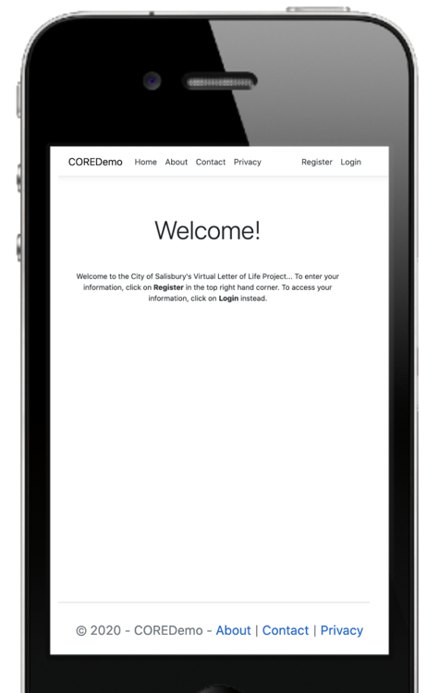

Figure 8 Home Page (Mobile)

**Internal UI functionality**:

When it comes to internal functionality, the systems users are populated when users choose to register within the system. The register option is presented here along with the option to sign in.

**External UI functionality**:

Externally this page presents the user with options to find more information regarding the VLOL system. The options are About, Contact and Privacy.

### **Register**

### **Screen Name:** VLOL (Virtual Letter of Life) Registration Page

**Requirement ID:** REQ-1.3

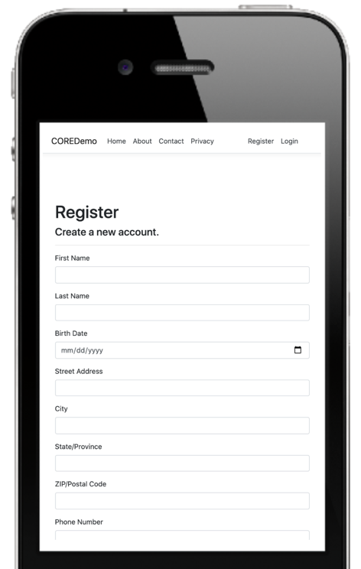

Figure 9 Registration Page (Mobile)

**Internal UI functionality**:

When it comes to internal functionality, the systems users are populated when users choose to register within the system. Registration collects user data: First Name, Last Name, DOB, Address, City, State, Zip, Phone Number, Email, SSN, Insurance Company, Insurance Policy, Primary Doctor, Primary Doctor Phone, Additional Information, and Password.

**External UI functionality**:

The registration page functionality effects external users by allowing them to store user credentials into the system. (Username and Password) this is used to allow access to the system.

### **Login**

### **Screen Name:** VLOL (Virtual Letter of Life) Log In Page

**Requirement ID:** REQ-1.4, REQ-1.11, REQ-1.18,and REQ-1.26

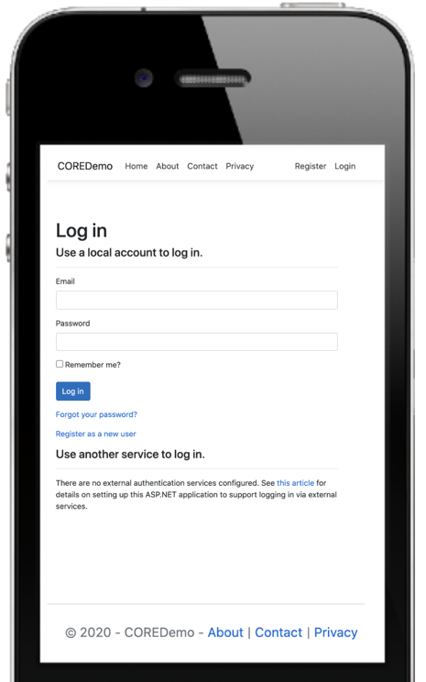

Figure 10 Login Page (Mobile)

**Internal UI functionality**:

This login page does not provide any internal functionality.

**External UI functionality**:

This is the interface that provides system access to external users upon verification of credentials.

### **About**

### **Screen Name:** VLOL (Virtual Letter of Life) About Page

**Requirement ID:**

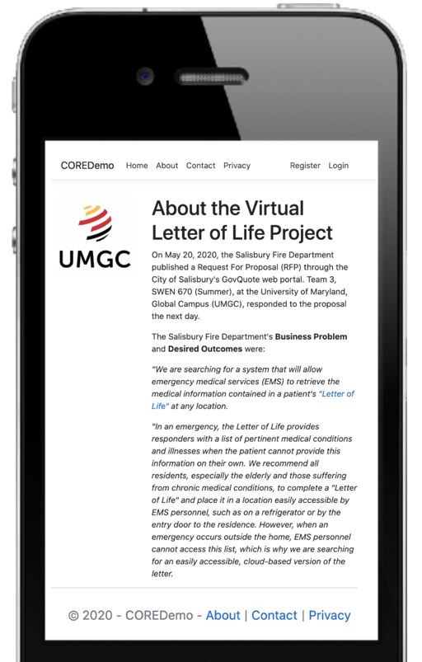

Figure 11 About Page (Mobile)

**Internal UI functionality**:

Internal functionality is not granted to external users from the About Page.

**External UI functionality**:

The About Page is designed to give users a background of the VLOL system and what it is used for.

### **Contact**

### **Screen Name:** VLOL (Virtual Letter of Life) Contact Page

**Requirement ID:** REQ-1.2, REQ-1.10,and REQ-1.17

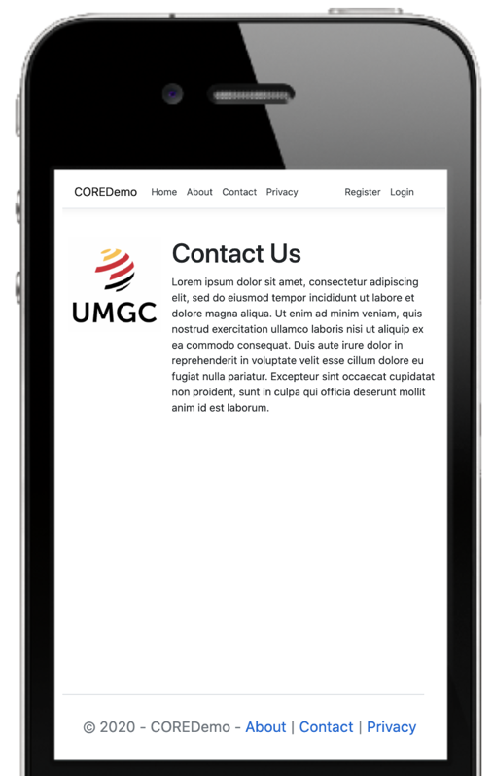

Figure 12 Contact Page (Mobile)

**Internal UI functionality**:

Internal functionality is not present from the Contact Page.

**External UI functionality**:

The Contact Page is designed to give users information regarding contacting the Virtual Letter of Life team.

### **Privacy**

### **Screen Name:** VLOL (Virtual Letter of Life) Privacy Page

**Requirement ID:**

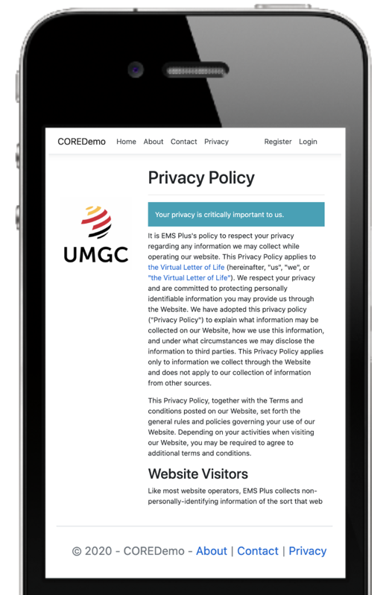

Figure 13 Privacy Policy Page (Mobile)

**Internal UI functionality**:

Internal functionality is not present from the Privacy Page.

**External UI functionality**:

The Privacy Page is designed to provide users with a guarantee of how their private data is to be handled by the Virtual Letter of Life System.